

**MALAYSIA-JAPAN INTERNATIONAL INSTITUTE OF TECHNOLOGY**

**(DEPARTMENT OF ELECTRONIC SYSTEM ENGINEERING)**

**MICROPROCESSOR AND MICROCONTROLLER**

REPORT

FULL BLINKING AND HALF BLINKING

|  |  |
| --- | --- |
| NAME | MATRIC NO |
| MUHAMMAD HAFIZUDDIN BIN REDZUAN | B17MJ0015 |
| NUR AIDA HAMIZAH BINTI KAMARUDIN | B17MJ0023 |
| NUR AZREENA BINTI MD AZMAN | B17MJ0024 |

INTRODUCTION:

Similar to printing ‘Hello World’ in C or C++, the very first step towards programming a microcontroller is “blinking a LED” with a delay. For this project, we are required to do two task which are full blinking LED and half blinking LED. There are 8 LEDs at the microcontroller board kit which is if 8 LEDs are blinking at the same time it means full blinking while if 4 LEDs are blinking at the same time are half blinking.

OBJECTIVE:

* To be able to write programs with the task given.
* To be able to run the programs written based on the task given on the microcontroller board kit.

TASK:

Students are required to write a programming for full blinking and half blinking and run the program and the output will show on the microcontroller board kit.

EQUIPMENTS AND COMPONENTS:

* Microcontroller circuit board.
* Keil Embedded Programs.

RESULT AND SIMULATION:

A.FULL BLINKING

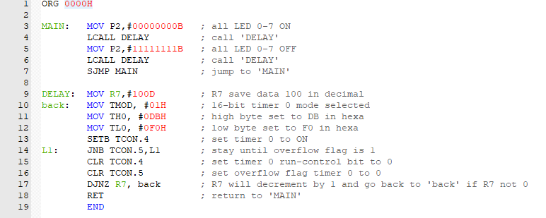

1. LED is control by port 2 from LED 0 to LED 7.
2. Port 2 is set 00H for LED to on since the LED is active-LOW so that all the LED will ON
3. DELAY is called so it will jump to DELAY to be executed to next instruction
4. R7 data is set to 100 in decimal
5. Timer mode will set to 01 in hexa to select 16-bit timer 0
6. For crystal oscillator, there need to make timer count up to 10 000 since 1 machine cycles is 1µs. So, 65 536 (full timer count for crystal oscillator) must minus 10 000, 65 536 – 10 000 = 55 536 = DBF0H
7. TH0 is for high byte set so DB will be set while TH1 is for low byte set so F0 will be set
8. TCON.4 is for Timer 0 run-control bit so it will be set 1 to timer start counting
9. The instruction for timer count will keep remain until overflow flag is 1. In other words, Timer 0 finish counting.
10. TCON.4 and TCON.5 will set back to 0 to be ready to execute next instruction
11. R7 will decrement by 1 so, R7 data now is 99 and instruction will execute ‘back’ until R7 decrease until 0.
12. After R7 become 0 the instruction will execute to the first instruction which is ‘MAIN’. This will give LED to on ON for 100 x 10ms = 1s
13. Then, the same cycle will be execute but for port 2 FFH. So, the LED will OFF for another 1s
14. Lastly, instruction will execute short jump (SJMP) to ‘MAIN’ to rotating the ON OFF cycle for the LED and this will lead to LED blinking for a delay 1s.

B.HALF BLINKING

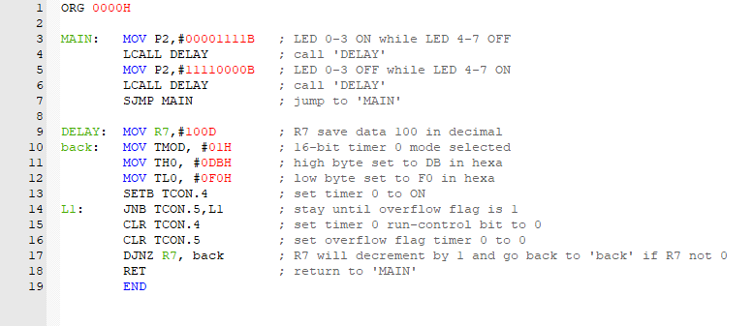

1. LED is control by port 2 from LED 0 to LED 7.
2. Port 2 is set 0FH for LED to on since the LED is active-LOW so that all the LED 0-3 will ON while LED 4-7 will OFF
3. DELAY is called so it will jump to DELAY to be executed to next instruction
4. R7 data is set to 100 in decimal
5. Timer mode will set to 01 in hexa to select 16-bit timer 0
6. For crystal oscillator, there need to make timer count up to 10 000 since 1 machine cycles is 1µs. So, 65 536 (full timer count for crystal oscillator) must minus 10 000, 65 536 – 10 000 = 55 536 = DBF0H
7. TH0 is for high byte set so DB will be set while TH1 is for low byte set so F0 will be set
8. TCON.4 is for Timer 0 run-control bit so it will be set 1 to timer start counting
9. The instruction for timer count will keep remain until overflow flag is 1. In other words, Timer 0 finish counting.
10. TCON.4 and TCON.5 will set back to 0 to be ready to execute next instruction
11. R7 will decrement by 1 so, R7 data now is 99 and instruction will execute ‘back’ until R7 decrease until 0.
12. After R7 become 0 the instruction will execute to the first instruction which is ‘MAIN’. This will give LED to on ON for 100 x 10ms = 1s
13. Then, the same cycle will be execute but for port 2 F0H. So, the LED 0-3 will OFF while LED 4-7 will ON for another 1s
14. Lastly, instruction will execute short jump (SJMP) to ‘MAIN’ to rotating the ON OFF cycle for the LED and this will lead to LED blinking for a delay 1s.

CONCLUSION:

Conclusions, the programs that we made are using timer instead of delays but the output are equal with the task given where full blinking and half blinking are shown on the microcontroller circuit board.

REFERENCE:

* <https://electrosome.com/blinking-led-atmega32-avr-microcontroller/>